ERROR MODELLING AND SELF CALIBRATION OF A LOW COST STRAPDOWN INERTIAL NAVIGATION SYSTEM FOR ROBOTIC MOTION TRACKING

A PROJECT REPORT

Submitted by

AZHAGAR AADITHYAN A V | 22MT001
HARRY DEEPAK A | 22MT020

in partial fulfillment for the award of the degree

of

BACHELOR OF ENGINEERING

in

MECHATRONICS ENGINEERING






CHENNAI INSTITUTE OF TECHNOLOGY (AUTONOMOUS)
(Affiliated to Anna University, Chennai)
CHENNAI-600 069


ANNA UNIVERSITY: CHENNAI-600 025
MARCH-2026
ANNA UNIVERSITY: CHENNAI-600 025

BONAFIDE CERTIFICATE

Certified that this project report “ERROR MODELLING AND SELF CALIBRATION OF A LOW COST STRAPDOWN INERTIAL NAVIGATION SYSTEM FOR ROBOTIC MOTION TRACKING” is the Bonafide work of “AZHAGAR AADITHYAN A V (22MT001), HARRY DEEPAK A (22MT020)” who carried out the project work under my supervision.

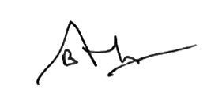

SIGNATURE  Dr. S. CHANDRAVANDHANA  M.E, Ph.D.,  HEAD OF DEPARTMENT,  Professor,  Department of Mechatronics  Engineering.  Chennai Institute of Technology,  Chennai - 600069 | SIGNATURE  Dr. B. ANUSHRAJ  M.E, Ph.D.,  SUPERVISOR,  Assistant Professor,  Department of Mechatronics  Engineering,  Chennai Institute of Technology, Chennai - 600069

Certified that the above students have attend of viva voce during the exam held on 9 March 2026 .

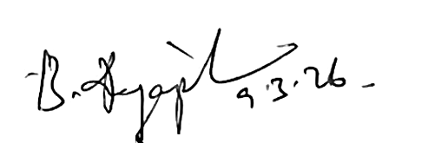
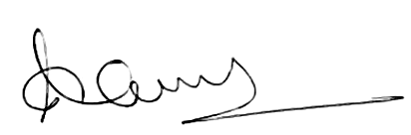

INTERNAL EXAMINER EXTERNAL EXAMINER

ACKNOWLEDGEMENT

We express our gratitude to our Chairman Shri.P.SRIRAM and all trust members of Chennai institute of technology for providing the facility and opportunity to do this project as a part of our undergraduate course.

We are grateful to our Principal Dr.A.RAMESH M.E, Ph.D. for providing us the facility and encouragement during the course of our work.

We sincerely thank our Head of the Department,
Dr. S. CHANDRAVANDHANA, M.E, Ph.D. Department of Mechatronics Engineering for having provided us valuable guidance, resources and timely suggestions throughout our work.

We sincerely thank our Project Guide, Dr. B. ANUSHRAJ, M.E, Ph.D. Assistant Professor, Department of Mechatronics Engineering for having provided us valuable guidance, resources and timely suggestions throughout our work.

We would like to extend our thanks to our Faculty Coordinators of the Department of Mechatronics Engineering, for their valuable suggestions throughout this project.

We wish to extend our sincere thanks to all Faculty members of the Department of Mechatronics Engineering for their valuable suggestions and their kind cooperation for the successful completion of our project.

We wish to acknowledge the help received from the Lab Instructors of the Department of Mechatronics Engineering and others for providing valuable suggestions and for the successful completion of the project.

AZHAGAR AADITHYAN A V HARRY DEEPAK A

ABSTRACT

Accurate localization in GPS-denied environments remains a fundamental challenge in mobile robotics, particularly when low-cost MEMS-based inertial sensors are employed. Although compact and economically viable, such sensors are highly susceptible to bias, scale factor errors, and stochastic noise, leading to rapid drift in velocity and position estimation. Addressing these limitations requires systematic calibration and robust state estimation techniques to ensure reliable navigation performance.
This work develops and experimentally validates a low-cost strapdown inertial navigation system (INS) integrated within a ROS-based robotic framework. Deterministic sensor errors were mitigated using an ellipsoid fitting calibration algorithm, which compensates bias offsets and distortion effects in inertial measurements. To reduce stochastic noise and dynamic bias variations, an Extended Kalman Filter (EKF) was implemented for nonlinear state estimation of orientation, velocity, and position. The complete system was deployed on a Raspberry Pi Zero 2W–based mobile robotic platform and evaluated through real-time trajectory experiments.
Experimental results demonstrate that standalone inertial navigation leads to significant drift, whereas the combined application of calibration and EKF filtering substantially improves orientation stability and trajectory tracking accuracy. Real-time visualization using RViz confirmed the reduction in path deviation between raw and filtered odometry outputs. The developed framework establishes a practical and scalable foundation for low-cost indoor navigation and future multi-sensor fusion–based autonomous robotic systems.

TABLE OF CONTENTS
CHAPTER NO. | TITLE | PAGE NO.
 | ABSTRACT | v
 | LIST OF TABLES | ix
 | LIST OF FIGURES | x
 | LIST OF SYMBOLS & ABBREVIATIONS | xi
 | INTRODUCTION | 1
 | - INERTIAL NAVIGATION SYSTEM | 1
 | 1.2 BACKGROUND AND MOTIVATION | 2
 | 1.3 STRAPDOWN INERTIAL NAVIGATION SYSTEMS | 3
 | 1.4 ROLE OF RASPBERRY PI IN THE SYSTEM | 4
 | 1.5 PROBLEM STATEMENT | 5
 | 1.6 PROJECT OVERVIEW | 6
 | 1.7 CHOICE OF DIFFERENTIAL DRIVE CONFIGURATION | 7
 | 1.8 NEED FOR INFRASTRUCTURE-INDEPENDENT NAVIGATION | 8
 | LITERATURE REVIEW | 10
 | 2.1 INTRODUCTION TO MEMS-BASED INERTIAL NAVIGATION | 10
 | 2.2 ERROR SOURCES IN MEMS IMU SENSORS | 11
 | 2.3 STRAPDOWN INS AND ERROR PROPAGATION ANALYSIS | 11
 | 2.4 IMU CALIBRATION METHODS IN LITERATURE | 12
 | 2.4.1 Static Calibration Techniques | 12
 | 2.4.2 Ellipsoid Fitting Algorithm | 13
 | 2.5 COMBINED CALIBRATION AND FILTERING APPROACHES | 13
 | 2.6 INERTIAL NAVIGATION IN ROBOTIC APPLICATIONS | 14
 | 2.7 ADVANCED ERROR MODELING IN MEMS IMU | 14
 | 2.8 COMPARATIVE ANALYSIS OF CALIBRATION AND FILTERING APPROACHES | 15
 | 2.9 RESEARCH GAP | 15
 | 2.10 SUMMARY OF LITERATURE SURVEY | 16
 | 2.11 OBJECTIVES | 17
 | 2.12 METHODOLOGY | 17
3. | EXPERIMENTAL SETUP | 18
 | 3.1 SYSTEM OVERVIEW | 19
 | 3.2 HARDWARE ARCHITECTURE | 19
 | 3.2.1 ICM-20948 Imu Sensor  3.2.1 Listoftask In Constructionsite | 21
 | 3.2.2 ESP8266 Microcontroller | 22
 | 3.2.3 Raspberry Pi Zero 2w (Ros Core) | 22
 | 3.2.4 L298 Motor Driver | 23
 | 3.2.5 OLED Display | 24
 | 3.3 CALIBRATION AND FILTERING FRAMEWORK | 25
 | 3.3.1 Ellipsoid Fitting Calibration | 25
 | 3.3.2 Extended Kalman Filter | 26
 | 3.4 STRAPDOWN NAVIGATION AND MOTION L | 27
 | 3.5 PATH ACCURACY EVALUATION | 28
 | 3.6 RVIZ VISUALIZATION FRAMEWORK | 28
 | 3.7 ROBOTIC PLATFORM FOR EXPERIMENTAL | 30
 | 3.7.1 CAD Model of the Robotic Platform | 30
 | 3.7.2 Hardware Prototype Implementation | 32
4 | RESULTS AND DISCUSSION | 33
 | 4.1 SIMULATION RESULTS | 33
 | 4.1.1 Simulation Setup | 33
 | 4.1.2 Raw Strapdown Navigation Results (Without Calibration) | 34
 | 4.1.3 Ellipsoid Calibration Effect | 35
 | 4.1.4 Extended Kalman Filter Performance | 36
 | 4.1.5 Extended Simulation Discussion | 36
 | 4.1.6 Kalman Filter Performance | 38
 | 4.2 HARDWARE DEVELOPMENT RESULTS | 38
 | 4.2.1 Raw Imu Behaviour (Without Calibration) | 38
 | 4.2.2 Effect of Ellipsoid Calibration on Hardware | 39
 | 4.2.3 EKF-Based Hardware Results | 40
 | 4.2.4 Quantitative Analysis | 40
 | 4.2.5 Raw Vs Calibrated Trajectory in Rviz | 41
 | 4.2.6 OLED Accuracy Output | 42
 | 4.2.7 Hardware Performance Discussion | 42
 | 4.3 DISCUSSION | 42
5 | CONCLUSIONS AND FUTURE WORK | 45
 | 5.1 CONCLUSIONS | 45
 | 5.2 FUTURE WORK | 45
 | REFERENCES | 47
 | APPENDIX | 49

LIST OF TABLES
Figure  No. | Title | Page  No.
2.1 | Comparison of different algorithm | 15
4.1 | Comparison of Modes | 30
4.2 | Accuracy Range | 41

LIST OF FIGURES
Table  No. | Title | Page  No.
3.1 | Flowchart of System | 18
3.2 | ICM 20948 IMU Sensor | 19
3.3 | ESP8266 Microcontroller | 22
3.4 | Raspberry Pi Zero 2W | 23
3.5 | L298 Motor Controller | 24
3.6 | OLED Display | 25
3.7 | RVIZ Platform showing Movement of mobile robot | 29
3.8 | CAD model of the mobile robot | 31
3.9 | Mobile robot used to collect data | 32
4.1 | Raw vs Calibrated data comparison of Ellipsoid fitting algorithm | 35
4.2 | Linear motion of Bot | 37
4.2 | Rectangular motion of Bot | 37
4.3 | Quantitative analysis of stability of data | 41

LIST OF SYMBOLS AND ABBREVIATIONS

3D | - | Three Dimensional
IMU | - | Inertial Measurement Unit
SINS | - | Strapdown Inertial Navigation System
MEMS | - | Micro-Electro-Mechanical Systems
EKF | - | Extended Kalman Filter
ROS | - | Robot Operating System
GPS | - | Global Positioning System
DOF | - | Degrees of Freedom
MCU | - | Microcontroller Unit
I2C | - | Inter-Integrated Circuit
SPI | - | Serial Peripheral Interface
PWM | - | Pulse Width Modulation
CAD | - | Computer-Aided Design
RMS | - | Root Mean Square
OLED | - | Organic Light Emitting Diode
PID | - | Proportional Integral Derivative
UART | - | Universal Asynchronous Receiver Transmitter
ADC | - | Analog to Digital Converter

CHAPTER 1
INTRODUCTION
  - INERTIAL NAVIGATION SYSTEM
An Inertial Navigation System (INS) is a self-contained navigation technique used to determine the position, velocity, and orientation of a moving object without relying on external references[1]. Unlike satellite-based navigation systems such as GPS, an INS operates independently by processing measurements from internal sensors[2]. These sensors typically include accelerometers, which measure linear acceleration, and gyroscopes, which measure angular velocity[3]. In many modern systems, magnetometers are also included to enhance heading estimation[4].
The fundamental principle of inertial navigation is based on Newton’s laws of motion. Linear acceleration measured by accelerometers is integrated once to obtain velocity and integrated twice to estimate position[1], [3]. Similarly, angular velocity measured by gyroscopes is integrated to determine orientation[5]. By continuously updating these calculations, the system estimates the trajectory of the moving body in three-dimensional space[1].
Inertial navigation systems are widely used in aerospace, defense, marine vessels, submarines, guided missiles, spacecraft, and aircraft due to their reliability and independence from external infrastructure[1]. In recent years, advances in Micro-Electro-Mechanical Systems (MEMS) technology have enabled the development of compact and low-cost Inertial Measurement Units (IMUs), expanding their applications to robotics, autonomous vehicles, drones, smartphones, wearable devices, and automotive driver assistance systems[6], [7].
In automotive systems, INS plays a vital role in dead reckoning during temporary GPS outages such as in tunnels, under bridges, or in dense urban environments[8]. In robotics, inertial navigation assists in motion tracking, balance estimation, mapping, and control applications[7]. Despite these advantages, a major challenge associated with inertial navigation is error accumulation over time due to sensor imperfections[9].
  - BACKGROUND AND MOTIVATION
With the rapid growth of robotics and intelligent transportation systems, accurate localization has become a fundamental requirement[8]. While GPS provides reliable outdoor navigation, it suffers from major limitations in indoor environments, underground facilities, industrial warehouses, parking structures, and urban canyons where satellite signals may be blocked or degraded[1], [8].
To overcome these limitations, inertial navigation provides a promising alternative[1]. MEMS-based IMUs have made inertial sensing affordable and accessible for small robotic and embedded systems[6]. However, unlike high-grade navigation sensors used in aerospace systems, low-cost MEMS sensors suffer from significant deterministic and stochastic errors[9]. These include bias drift, scale factor mismatches, random noise, axis misalignment, and magnetic distortions[9], [10].
Because inertial navigation requires continuous mathematical integration of sensor outputs, even minor measurement errors accumulate over time[3]. Accelerometer bias leads to quadratic growth in position error, while gyroscope bias results in increasing orientation error[1], [3]. These errors propagate within the strapdown navigation equations, leading to substantial trajectory drift[1], [5].
This creates a strong motivation for improving inertial navigation accuracy using intelligent software-based correction techniques[11], [12]. Rather than relying on expensive hardware upgrades or continuous external corrections, this project focuses on enhancing performance through calibration algorithms and filtering methods[4], [13].
The motivation of this work is therefore to develop a low-cost strapdown inertial navigation system capable of operating in GPS-denied environments with improved accuracy through systematic calibration and noise filtering[6], [9].
  - STRAPDOWN INERTIAL NAVIGATION SYSTEMS
Modern embedded inertial systems primarily use the strapdown configuration[1]. In a Strapdown Inertial Navigation System (SINS), sensors are rigidly mounted (or “strapped down”) to the moving body[3]. Instead of mechanical gimbals used in traditional systems, coordinate transformations are computed mathematically using rotation matrices or quaternion representations199[5], [14].
In a strapdown system, the gyroscope measures angular velocity in the body frame[5]. These measurements are integrated to compute orientation. Accelerometer measurements, which are initially expressed in the body coordinate frame, are then transformed into the navigation frame using the estimated orientation[1]. After removing gravitational acceleration, the resulting specific force is integrated to estimate velocity and position[1].
The strapdown approach offers advantages such as reduced mechanical complexity, compact size, lower cost, and compatibility with MEMS sensors. However, it is highly sensitive to sensor errors[1], [6]. Any bias in gyroscope measurements affects orientation accuracy, which subsequently affects acceleration transformation[9]. This coupling amplifies error propagation within the navigation algorithm[3], [5].
Therefore, strapdown inertial systems require robust calibration and filtering strategies to maintain acceptable navigation performance[11], [15].
  - ROLE OF RASPBERRY PI IN THE SYSTEM
The Raspberry Pi serves as the central processing and control unit of the proposed strapdown inertial navigation system. It provides sufficient computational capability to execute the Robot Operating System (ROS), implement the Extended Kalman Filter (EKF), and perform real-time sensor data processing and visualization[11], [15]. The availability of a Linux-based operating system enables seamless integration with robotics frameworks, libraries, and development tools, thereby simplifying system development and debugging.
In addition to its processing capabilities, the Raspberry Pi offers versatile hardware interfacing options, including GPIO, I2C, and SPI communication protocols, which facilitate direct and reliable integration with the MEMS-based IMU and other peripheral devices. Its compact form factor and low power consumption make it suitable for embedded robotic applications, while remaining significantly more cost-effective than industrial-grade embedded controllers. Furthermore, the extensive developer community and well-documented software ecosystem enhance development efficiency and long-term maintainability of the system.
Alternative platforms were carefully evaluated before final selection. Arduino-based microcontrollers, although suitable for basic embedded control tasks, were not chosen due to their limited processing power, which is insufficient for running ROS and executing computationally intensive EKF algorithms[11]. The NVIDIA Jetson Nano, while offering higher computational performance and GPU acceleration, was considered unnecessary for this application and economically inefficient due to its higher cost and excess processing capability. Similarly, STM32-based microcontrollers provide strong real-time embedded performance but lack the computational flexibility required for full ROS integration and advanced navigation algorithm implementation.
For this project, the Raspberry Pi Zero 2 W was specifically selected as it provides an optimal balance between computational capability, size, power consumption, and cost. Despite its compact form factor, it features a quad-core processor capable of handling ROS nodes and real-time filtering algorithms efficiently for small-scale robotic applications. Its integrated Wi-Fi and Bluetooth connectivity enable wireless communication, remote monitoring, and web-based control without additional hardware modules. Moreover, its lightweight and minimal power requirements make it highly suitable for a two-wheeled mobile robotic platform where space and energy efficiency are critical constraints.
Therefore, the Raspberry Pi Zero 2 W was chosen as a practical and economical solution that satisfies the computational and integration requirements of the proposed low-cost strapdown inertial navigation framework while maintaining portability and scalability.
  - PROBLEM STATEMENT
Low-cost MEMS-based IMUs introduce both systematic and random errors that degrade the accuracy of strapdown inertial navigation systems[6], [15]. When raw sensor outputs are directly used in navigation equations, error accumulation leads to rapid drift in orientation and position estimates2004[1], [3].

- Systematic errors include:
- Bias offsets
- Scale-factor distortion
- Axis misalignment
- Magnetic field distortions[4], [16]
- Random errors include:
- Measurement noise
- Outliers
- Temperature-induced variations[9], [17]

Although hybrid navigation systems can combine INS with GPS, LiDAR, cameras, or wheel encoders to compensate for drift[18], [19], such systems increase cost and hardware complexity. Furthermore, certain environments restrict the use of external references.
The problem addressed in this project is, How to reduce drift and improve accuracy in a low-cost strapdown inertial navigation system using systematic calibration and real-time filtering techniques without relying on continuous external correction sources[10], [11].
  - PROJECT OVERVEIW
This project presents the design and implementation of a low-cost strapdown inertial navigation system for robotic motion tracking[1]. The system utilizes a MEMS-based IMU consisting of accelerometer, gyroscope, and magnetometer sensors[6]. The proposed framework integrates two major enhancement techniques:
Ellipsoid Fitting Algorithm for static calibration of accelerometer, gyroscope, and magnetometer sensors[4], [10].
Extended Kalman Filter (EKF) for dynamic noise filtering, outlier rejection, and real-time state estimation[11], [14].

The ellipsoid fitting algorithm corrects systematic sensor distortions by estimating bias and scaling parameters[4]. Sensor outputs that naturally form an ellipsoid due to imperfections are mathematically transformed into a normalized spherical distribution, achieving accurate calibration.
After calibration, an Extended Kalman Filter is implemented to filter stochastic noise and enhance state estimation[11], [15]. The EKF operates recursively to refine orientation and motion parameters, improving robustness against random disturbances during real-time operation[11].
The system is first validated through simulation and then implemented on embedded hardware integrated with a robotic platform. Comparative performance analysis is conducted before and after applying calibration and filtering techniques to quantify navigation accuracy improvement.
  - CHOICE OF DIFFERENTIAL DRIVE CONFIGURATION
The two‑wheeled differential drive system was selected for this project due to its structural simplicity, controllability, and suitability for validating inertial navigation algorithms in a controlled indoor environment. Compared to complex multi‑wheel or omnidirectional platforms, a two‑wheeled configuration requires only two drive motors and a passive support wheel, which significantly reduces mechanical complexity, weight, and power consumption. This simplicity makes system integration more manageable and minimizes mechanical uncertainties that could otherwise affect navigation performance evaluation.
From a modeling perspective, the kinematics of a differential drive robot are well defined and mathematically straightforward. Linear and angular motion can be accurately controlled by independently varying the rotational speeds of the left and right wheels. This allows precise trajectory execution, making it easier to analyze drift, heading deviation, and position estimation errors generated by the inertial navigation system[8]. The reduced kinematic complexity also lowers computational requirements, which aligns well with the objective of implementing a low‑cost embedded navigation framework.
Furthermore, the compact size and energy efficiency of a two‑wheeled platform make it ideal for indoor experiments where space constraints and safety considerations are important. The platform provides sufficient manoeuvrability for straight-line motion, rotation, and curved path tracking, which are essential for testing calibration and filtering performance under different motion conditions.
Therefore, the two‑wheeled differential drive configuration was chosen as a practical, economical, and analytically convenient platform for implementing and experimentally validating the proposed strapdown inertial navigation system[1].
  - Need for Infrastructure-Independent Navigation
Accurate positioning is a fundamental requirement in modern robotic and automation systems[17]. Although the Global Positioning System (GPS) is widely adopted for outdoor navigation, its performance significantly degrades in indoor and obstructed environments[17]. Satellite signals are often blocked or distorted in tunnels, underground facilities, factories, dense urban regions, and enclosed structures, leading to signal loss, multipath errors, and reduced positioning reliability. Since this project focuses on indoor and GPS‑denied environments, reliance on GPS alone would not ensure continuous and stable localization.
To address this limitation, an Inertial Measurement Unit (IMU)‑based navigation approach was adopted[6]. Unlike GPS, an IMU operates independently of external infrastructure by directly measuring acceleration and angular velocity through onboard sensors. This enables continuous motion tracking regardless of environmental conditions[1]. Although inertial navigation systems are inherently affected by drift due to sensor imperfections, appropriate calibration and filtering techniques can significantly improve their accuracy[10], [11]. Therefore, an IMU‑based strapdown navigation framework was selected to ensure autonomous, reliable, and infrastructure‑independent operation suitable for the intended application domain

CHAPTER 2
LITERATURE SURVEY

  - INTRODUCTION TO MEMS-BASED INERTIAL NAVIGATION
Inertial navigation has been studied for many years, especially in aerospace and defence systems where accurate motion tracking is extremely important. Earlier inertial systems used high-grade sensors like Ring Laser Gyroscopes (RLG) and Fiber Optic Gyroscopes (FOG)[1]. These systems provided very high accuracy, but they were expensive, bulky, and consumed more power. Because of this, they were not suitable for small robotic or embedded systems.
With the development of Micro-Electro-Mechanical Systems (MEMS), inertial sensors became much smaller and affordable[6]. Today, MEMS-based IMUs are widely used in smartphones, drones, robotic platforms, wearable devices, and even automobiles[6], [7]. These sensors can measure acceleration, angular velocity, and sometimes magnetic field strength within a compact structure.
However, even though MEMS sensors are cost-effective and compact, they are not as accurate as navigation-grade sensors[9]. Researchers have repeatedly highlighted that low-cost IMUs suffer from bias drift, scale factor errors, misalignment, and noise[9], [17]. Because inertial navigation relies on continuous integration of measurements, even a small sensor error can slowly grow into a large position error over time. This is why improving MEMS-based inertial navigation has become an important research topic.

  - ERROR SOURCES IN MEMS IMU SENSORS
Most research studies divide IMU errors into two major types: deterministic errors and stochastic errors[9].
Deterministic errors are predictable and mostly constant in nature. These include bias offset, scale factor mismatch, and axis misalignment[16]. For example, even when the sensor is stationary, the accelerometer may not show exactly zero acceleration due to bias. Similarly, magnetometers are affected by nearby metallic objects, causing distortion[4].
On the other hand, stochastic errors are random and time-varying. These include white noise, bias instability, and random walk noise,p. These errors are harder to eliminate because they change during operation.
Researchers have shown that deterministic errors can usually be handled using calibration techniques. Stochastic errors, however, require filtering methods such as Kalman filtering to reduce their impact during real-time navigation[11], [15].
Understanding these error sources is essential before designing any correction algorithm, since each type of error must be addressed differently.
  - STRAPDOWN INS AND ERROR PROPAGATION ANALYSIS
In a strapdown inertial navigation system, sensors are fixed directly onto the moving body[3]. All coordinate transformations are done mathematically using rotation matrices or quaternions[5], [14]. The gyroscope data is integrated to calculate orientation, and accelerometer data is transformed into the navigation frame to estimate velocity and position.
Many researchers explain that strapdown systems are very sensitive to small sensor errors[3], [20]. If the gyroscope has even a slight bias, the estimated orientation will slowly drift over time. Once the orientation is incorrect, the acceleration transformation becomes inaccurate, which further affects velocity and position estimation.
This type of error propagation makes low-cost strapdown inertial systems unreliable unless proper correction methods are used[9], [20]. Several studies mathematically demonstrate that position error increases rapidly with time due to double integration of acceleration errors. That is why drift reduction techniques are always part of inertial navigation research[11].
  - IMU CALIBRATION METHODS IN LITERATURE
Calibration plays a very important role in improving IMU performance[19]. Many research works focus on removing systematic errors before the sensor is used for navigation.
    - Static Calibration Techniques
Traditional calibration methods involve keeping the sensor at known orientations and recording its output. By comparing measured values with expected gravitational values, bias and scale factors can be calculated[19]. These methods are simple but require controlled setups and manual effort.
Multi-position calibration is commonly used for accelerometers. The sensor is placed in different orientations, and offsets are calculated using gravity as a reference. While this approach reduces constant bias, it may not handle complex distortion effects completely

    - Ellipsoid Fitting Algorithm
In recent years, ellipsoid fitting algorithms have become popular for sensor calibration, especially for magnetometers and accelerometers[1]. Ideally, if a sensor is rotated in all directions, the magnitude of its measurement should remain constant and form a spherical shape in 3D space. However, due to bias and scaling errors, the measurements usually form an ellipsoid instead of a sphere[1].
The ellipsoid fitting algorithm estimates the bias vector and scaling matrix required to transform the ellipsoid into a sphere[1]. After this transformation, the sensor output becomes properly calibrated. This method is especially effective in correcting hard-iron and soft-iron distortions in magnetometers. Recent studies also apply this technique to accelerometers and gyroscopes for better systematic calibration[19].
The advantage of ellipsoid fitting is that it does not require expensive external equipment. It only needs data collected in multiple orientations, making it practical for embedded systems[1].
  - COMBINED CALIBRATION AND FILTERING APPROACHES
From the literature, it is clear that calibration alone is not sufficient to remove all errors[19]. While calibration fixes constant distortions, it does not handle time-varying noise.
Similarly, filtering methods such as Kalman filters work well for reducing random noise and drift during operation, but they depend on reasonably calibrated inputs for optimal performance. Because of this, many modern research approaches combine static calibration and dynamic filtering. In such systems, calibration is first applied to remove deterministic errors. After that, filtering algorithms are used to reduce stochastic noise and improve state estimation. This combined approach provides better stability and improved orientation accuracy compared to using only one method[11].
  - INERTIAL NAVIGATION IN ROBOTIC APPLICATIONS
In robotics, inertial navigation is often used for short-duration motion tracking and dead reckoning. Several studies show that with proper calibration, MEMS-based IMUs can provide acceptable performance for indoor navigation tasks[11], [12].
However, researchers also point out that long-duration standalone inertial navigation is still challenging due to unavoidable drift[3], [20]. To overcome this, many robotic systems integrate additional sensors such as cameras or LiDAR[18].
Even so, there is ongoing interest in developing improved low-cost inertial systems that can function reliably without continuous external correction[11], [20].
  - ADVANCED ERROR MODELING IN MEMS IMU
To better understand sensor noise behavior, researchers use methods such as Allan variance analysis[9]. This method helps identify bias instability and random walk components in sensor data. By modeling these noise characteristics correctly, filtering algorithms such as the Extended Kalman Filter can be designed more effectively[11], [12]. Proper noise modeling improves estimation accuracy and reduces unnecessary filter instability.
This area of research emphasizes that error modeling is just as important as calibration when designing a reliable navigation system[9].

  - COMPARATIVE ANALYSIS OF CALIBRATION AND FILTERING APPROACHES
Based on the reviewed literature, different techniques offer different advantages.
Table 2.1: Comparison of different algorithm
Technique | Purpose | Strength | Limitation
Multi-position Calibration | Static bias and scale correction | Simple and effective | Requires controlled setup
Ellipsoid Fitting Algorithm | Systematic distortion correction | Accurate bias & scaling estimation | Requires wide orientation data
Complementary Filter | Orientation smoothing | Lightweight implementation | Limited drift compensation
Extended Kalman Filter | Dynamic state estimation & noise filtering | Adaptive and recursive | Requires tuning
Hybrid Calibration + EKF | Combined static & dynamic correction | High overall accuracy | Higher computational cost

Static calibration methods are good at correcting fixed errors [19]. Ellipsoid fitting provides accurate distortion correction using mathematical modelling [11]. Filtering methods such as EKF are effective in reducing noise and handling dynamic bias changes [1].
Most recent studies agree that combining calibration techniques with filtering produces better overall results than using them separately
  - RESEARCH GAP
Although significant research has been conducted on MEMS-based inertial navigation, certain limitations remain[11], [20].
Many studies focus only on magnetometer calibration rather than applying ellipsoid fitting systematically to all sensors[1]. Some research concentrates only on filtering without performing strong pre-calibration[11]. Also, several implementations rely on hybrid sensor systems that increase overall hardware complexity[19].
There is still scope for developing a unified, low-cost inertial navigation framework that combines ellipsoid-based calibration with Extended Kalman filtering in a strapdown configuration and validates it through both simulation and real robotic experiments[3], [11].
  - SUMMARY OF LITERATURE SURVEY
MEMS-based inertial navigation systems (INS) are compact and cost-effective, their performance is significantly affected by sensor bias, scale factor errors, misalignment, and noise accumulation [11], [20]. In strapdown systems, these errors propagate through integration, resulting in rapid drift in velocity and position estimates. Calibration techniques such as ellipsoid fitting are widely adopted to compensate deterministic errors, including hard-iron and soft-iron distortions, bias offsets, and scaling mismatches, thereby improving measurement consistency and stability.
Furthermore, nonlinear filtering approaches such as the Extended Kalman Filter (EKF) are commonly used to reduce stochastic noise and enhance state estimation accuracy [11]. However, existing research often treats calibration and filtering as separate processes, with limited focus on their combined implementation in a compact embedded robotic platform. This project addresses that gap by integrating ellipsoid-based calibration and EKF filtering within a ROS-based system to improve navigation performance in indoor and GPS-denied environments.

  - OBJECTIVES
The objectives of this project are:
• To design and implement a low-cost strapdown inertial navigation system capable of accurately estimating orientation, velocity, and position using MEMS-based IMU sensors in GPS-denied environments.
• To enhance navigation accuracy by applying an Ellipsoid Fitting Algorithm for systematic sensor calibration and an Extended Kalman Filter for noise reduction, outlier suppression, and improved state estimation.
  - METHODOLOGY
To achieve the first objective, a strapdown inertial navigation framework was developed using a MEMS-based IMU consisting of an accelerometer, gyroscope, and magnetometer. The raw sensor data were acquired through an embedded interface and processed within a ROS-based environment. Orientation was estimated using quaternion-based integration of gyroscope data, while velocity and position were obtained through numerical integration of acceleration after gravity compensation. This established the baseline navigation system for operation in GPS-denied conditions.
To address the second objective, systematic sensor errors such as bias, scale factor distortion, and magnetic disturbances were corrected using an Ellipsoid Fitting Algorithm. The algorithm transformed distorted sensor measurements into normalized spherical distributions, thereby improving measurement consistency and heading stability.

CHAPTER 3
EXPERIMENTAL SETUP

  - SYSTEM OVERVIEW
The experimental setup is designed to implement a complete ROS-based strapdown inertial navigation system (INS) integrated with a two-wheeled robotic platform. The system performs real-time sensing, calibration, filtering, navigation computation, motion control, accuracy estimation, and trajectory visualization.
The overall data flow of the system is:
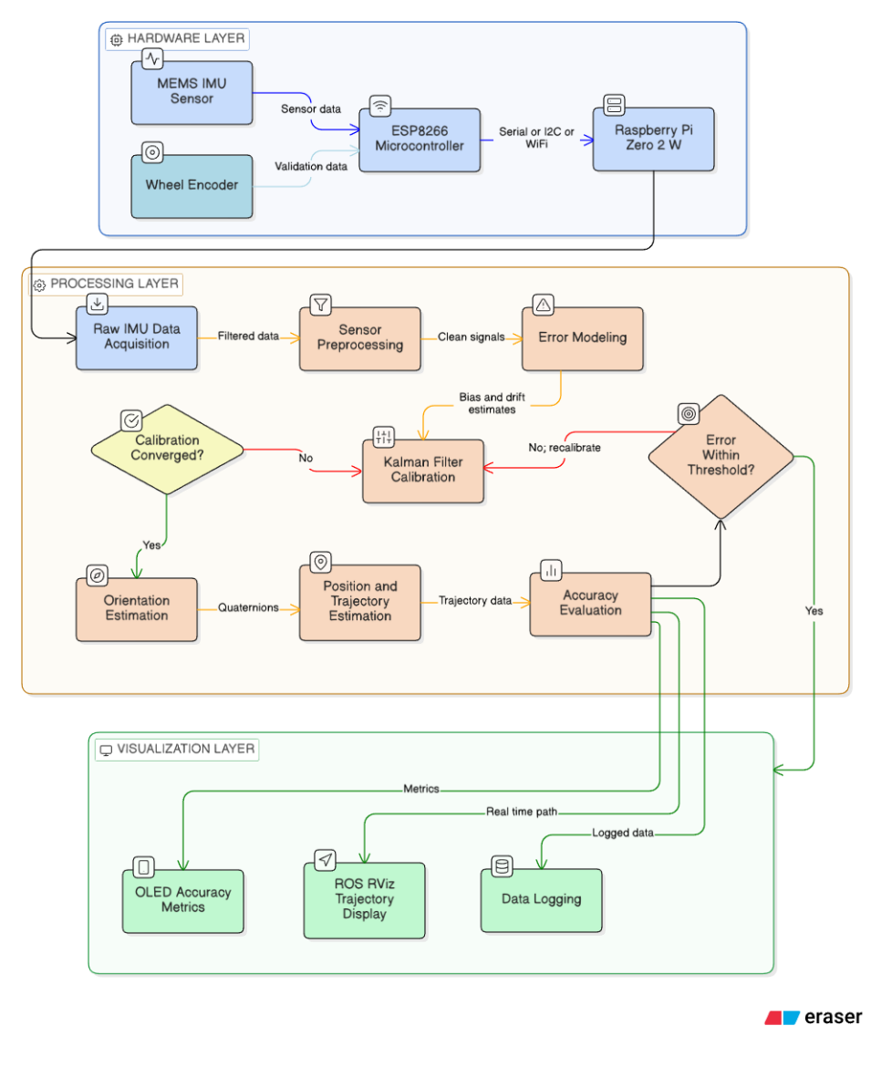
Fig 3.1: Flowchart of System
  - HARDWARE ARCHITECTURE
    - ICM‑20948 Imu Sensor
The ICM‑20948 is a 9‑axis MEMS motion tracking device integrating:
3-axis accelerometer
3-axis gyroscope
3-axis magnetometer (AK09916)
It operates with 16-bit resolution and provides digital output via I2C interface.
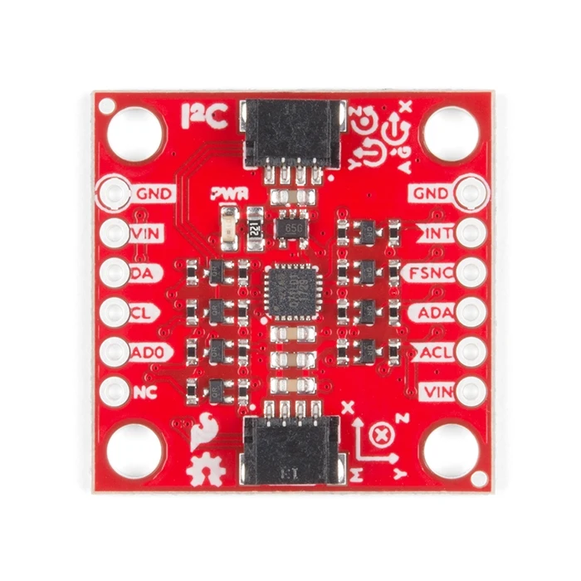
Fig 3.2: ICM 20948 IMU Sensor
- Accelerometer Configuration (Used)
The accelerometer used in this project operates with a full-scale measurement range of ±4g, which allows it to accurately capture moderate dynamic motions typically encountered in mobile robotic applications. It provides a sensitivity of 8192 LSB/g, ensuring precise conversion of acceleration values into digital signals for further processing. The sensor features a 16-bit resolution, enabling fine measurement granularity and improved detection of small variations in acceleration. With a noise density of approximately 230 µg/√Hz, the accelerometer maintains acceptable signal stability while still requiring filtering techniques to minimize noise influence. The sampling rate is configured at 100 Hz, which is sufficient for capturing real-time motion dynamics of the two-wheeled robotic platform without imposing excessive computational load on the processing unit.
Conversion:
$a(g)=\frac{Raw}{8192}$ … (3.1)
- Gyroscope Configuration (Used)
The gyroscope integrated into the system operates with a full-scale measurement range of ±500 degrees per second (dps), enabling accurate detection of moderate to high rotational motions typically encountered in mobile robotic applications. It provides a sensitivity of 65.5 LSB/dps, ensuring precise digital representation of angular velocity measurements for subsequent processing within the navigation algorithm. The sensor exhibits a noise density of approximately 0.015 dps/√Hz, indicating relatively low inherent measurement noise while still necessitating filtering techniques, such as the Extended Kalman Filter, to enhance stability and reduce drift in orientation estimation. These specifications make the gyroscope suitable for real-time strapdown inertial navigation and rotational motion tracking in the proposed robotic platform.
Conversion:
$ω(dps)=\frac{Raw}{65.5}$ … (3.2)
- Magnetometer Configuration (Used)
The magnetometer incorporated in the system operates within a measurement range of ±4900 µT, enabling it to accurately detect variations in the Earth’s magnetic field as well as surrounding magnetic disturbances. It provides a sensitivity of 0.15 µT per LSB, which ensures fine resolution in magnetic field measurement and supports precise heading estimation when fused with accelerometer and gyroscope data. The Output Data Rate (ODR) is configured at 100 Hz, allowing real-time acquisition of magnetic field measurements suitable for dynamic robotic motion. These specifications make the magnetometer effective for orientation correction and heading stabilization within the proposed strapdown inertial navigation framework.
Conversion:
$B(μT)=Raw×0.15$ … (3.3)
    - ESP8266 Microcontroller
The ESP8266 reads IMU data via I2C and transmits it to the RaspberryPi.
The ESP8266 module used in the system is powered by a 32‑bit Tensilica microprocessor, providing sufficient computational capability for real‑time sensor data handling and wireless communication tasks. It operates at a configurable clock frequency ranging from 80 MHz to 160 MHz, allowing a balance between processing performance and power consumption depending on system requirements. The module functions at an operating voltage of 3.3 V, making it compatible with low‑power embedded systems and MEMS-based sensors. In terms of communication interfaces, the ESP8266 supports I2C, Wi‑Fi, and UART protocols, enabling seamless data transmission between the IMU, the Raspberry Pi, and other peripheral devices. These specifications make it a suitable and cost‑effective choice for wireless data acquisition and embedded communication within the proposed navigation framework.

Functions:
- Sensor reading
- Timestamping
- Data packet transmission
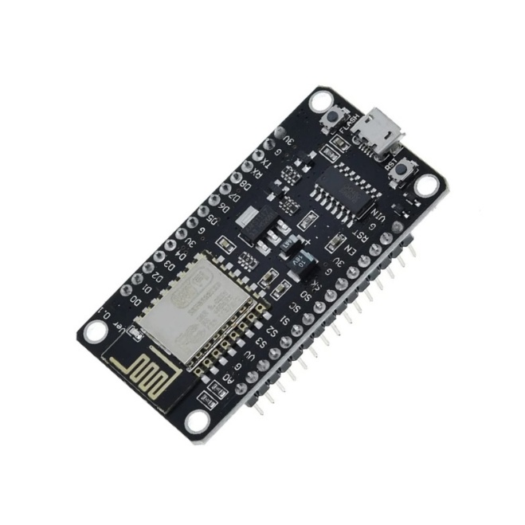
Fig 3.3: ESP8266 Microcontroller
    - Raspberry Pi Zero 2w (Ros Core)
The Raspberry Pi Zero 2W utilized in this system is equipped with a quad-core ARM Cortex-A53 processor, delivering sufficient computational performance to execute navigation algorithms and manage real-time sensor data processing. Operating at a clock frequency of 1 GHz, it ensures stable execution of the Extended Kalman Filter and related estimation routines without excessive power consumption. The board includes 512 MB of RAM, which is adequate for running lightweight robotic applications and maintaining efficient memory management under the Linux operating system. The support for a Linux-based OS enables seamless deployment of the Robot Operating System (ROS) framework, facilitating modular development, sensor integration, data visualization, and efficient communication within the overall inertial navigation architecture.

Handles:
- Calibration
- EKF Filtering
- Navigation Computation
- Motor Control
- Visualization Publishing
- Web Server
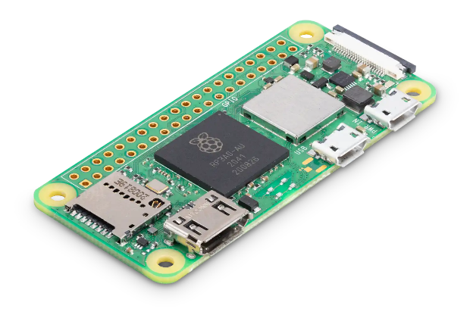
Fig 3.4: Raspberry Pi Zero 2W
    - L298 Motor Driver
Dual H-Bridge motor control module. Receives PWM and direction control signals from Raspberry Pi.
The L298 motor driver used in the proposed system operates within a wide voltage range of 5 V to 35 V, making it suitable for various robotic and embedded power configurations. It is capable of delivering up to 2 A per channel, allowing effective control of DC motors used in the two-wheeled mobile platform. The dual-channel capability enables independent control of two motors, supporting differential drive motion control for forward, reverse, and turning maneuvers. These specifications make the L298 a reliable and cost-effective solution for motor actuation in the developed inertial navigation-based robotic system.
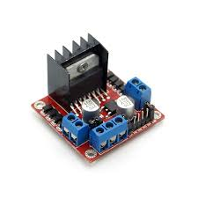
Fig 3.5: L298 Motor Controller

    - Oled Display
The OLED display integrated into the system features a resolution of 128 × 64 pixels, enabling clear and compact visualization of real‑time navigation parameters such as orientation, position accuracy, and system status. Despite its small form factor, the display provides sufficient graphical clarity for embedded monitoring and standalone verification without requiring external visualization tools. The module communicates using the I2C interface, which simplifies wiring and reduces the number of required communication pins. This efficient serial communication protocol ensures reliable data transfer between the display and the processing unit while maintaining low power consumption, making the OLED display well‑suited for compact robotic applications.
Displays real-time:
- Position
- Orientation
- Accuracy percentage
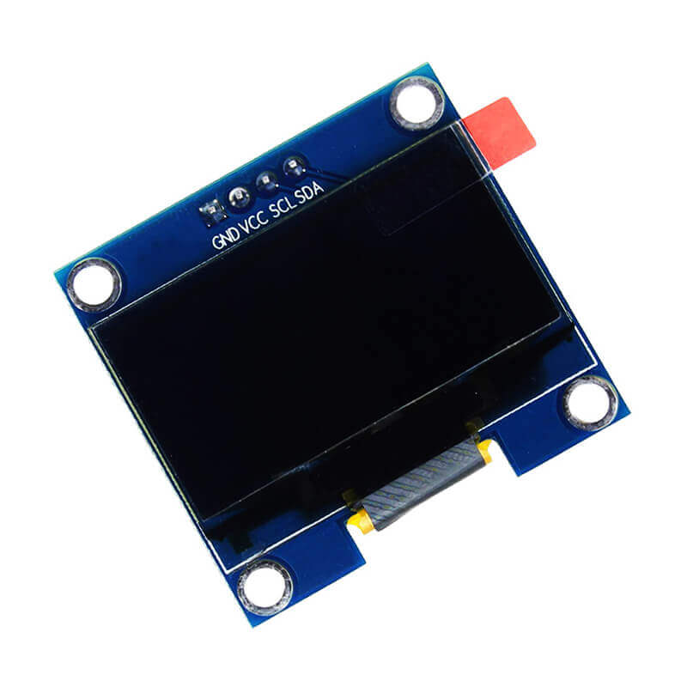
Fig 3.6: OLED Display
  - CALIBRATION AND FILTERING FRAMEWORK
    - Ellipsoid Fitting Calibration
Due to hard-iron bias, soft-iron distortion, scale factor and axis misalignment, raw measurements do not form a sphere. Instead, they form an ellipsoid.
The general sensor model is:
$U_{m}=AM+b$ … (3.4)
Where:
$U_{m}$: Raw measurement
$M$: True field vector
$A$: Distortion matrix
$b$: Bias vector
The ellipsoid equation is written as:
$x^{T}Cx+c^{T}x+d=0$ … (3.5)
Bias estimation:
$b=-\frac{1}{2}C^{-1}c$ … (3.6)
Eigen decomposition:
$C=RDR^{T}$ … (3.7)
Where:
$R$: Rotation matrix
$D$: Eigenvalue diagonal matrix
Scale normalization:
$N_{sf}=\frac{Field Magnitude}{Mean}$ … (3.8)
Final calibration:
$U_{cal}=C_{si}(U_{m}-b)$ … (3.9)
After transformation, the data approximates a unit sphere centered at origin.
    - Extended Kalman Filter
State vector:
$x=\left[\begin{aligned}q \\ v \\ p \\ b_{g} \\ b_{a}\end{aligned}\right]$ … (3.10)
Quaternion propagation:
$\dot{q}=\frac{1}{2}Ω(ω-b_{g})q$ … (3.11)
Velocity update:
$\dot{v}=R(q)(a-b_{a})+g$ … (3.12)
Position update:
$\dot{p}=v$ … (3.13)
Prediction:
$x_{k∣k-1}=f(x_{k-1})$ … (3.13)
Covariance:
$P_{k∣k-1}=FPF^{T}+Q$ … (3.14)
Kalman gain:
$K=PH^{T}(HPH^{T}+R)^{-1}$ … (3.15)
Update:
$x_{k}=x_{k∣k-1}+K(z-h(x))$ … (3.16)
EKF reduces drift accumulation and compensates bias.
  - STRAPDOWN NAVIGATION AND MOTION CONTROL
Quaternion to rotation matrix:
$a_{n}=R(q)a_{b}$ … (3.17)
Gravity removal:
$a_{n}=a_{n}-g$ … (3.18)
Velocity:
$v=v+a_{n}Δt$ … (3.19)
Position:
$p=p+vΔt$ … (3.20)
Error computation:
$e=p_{desired}-p_{estimated}$ … (3.21)
Motor correction (PD control):
$PWM=K_{p}e+K_{d}\dot{e}$ … (3.22)
This ensures path correction in real time.

  - PATH ACCURACY EVALUATION
Linear motion error:
$Error=∣d_{actual}-d_{commanded}∣$ … (3.23)
Accuracy:
$Accuracy(\%)=\left(1 − \frac{Error}{Commanded}\right)×100$ … (3.24)
For rectangular trajectory:
$RMS=\sqrt{\frac{1}{N}∑(p_{ideal}-p_{actual})^{2}}$ … (3.25)

  - RVIZ VISUALIZATION FRAMEWORK
The Robot Operating System (ROS) framework manages the structured flow of navigation data within the system. It continuously publishes raw IMU measurements, calibrated IMU outputs, raw odometry estimates obtained through direct integration, and filtered odometry generated by the Extended Kalman Filter. This modular publishing architecture enables independent processing nodes, efficient debugging, and real-time data exchange between sensing, estimation, and control modules. Such a distributed framework enhances scalability and simplifies the integration of additional sensors or algorithms in future extensions.
For visualization and analysis, RViz serves as an interactive 3D visualization tool integrated within the ROS ecosystem. It provides a graphical representation of sensor data, coordinate frames, and robot motion in real time. In this project, RViz displays both the raw drifted trajectory and the corrected calibrated path simultaneously, allowing direct visual comparison of navigation performance before and after filtering. It also renders orientation axes and reference frames, helping to analyze roll, pitch, and yaw behavior during motion. The real-time trajectory visualization enables continuous monitoring of position estimation accuracy and system stability. By offering intuitive graphical feedback, RViz significantly aids in debugging, performance validation, and demonstration of the effectiveness of the calibration and filtering framework. This visually demonstrates effectiveness of calibration and EKF.
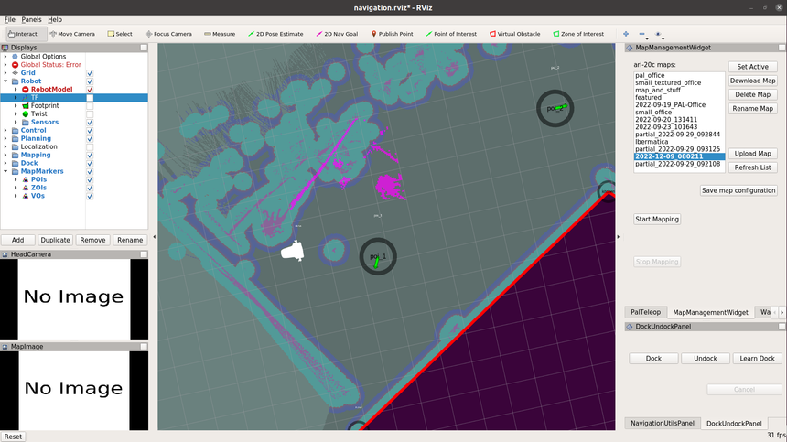
Fig 3.7: RVIZ Platform showing Movement of mobile robot
  - Robotic Platform for Experimental Validation
A two-wheeled differential drive robot was used as the experimental platform to validate the proposed inertial navigation system under real motion conditions. The IMU sensor was rigidly mounted on the robot body to ensure accurate measurement of acceleration and angular velocity during movement.
The system consists of a Raspberry Pi as the main processing unit, an IMU module for data acquisition, an L298 motor driver, and two DC geared motors. The IMU continuously collects tri-axial accelerometer, gyroscope, and magnetometer data, which is transmitted to the Raspberry Pi for calibration, EKF-based filtering, and navigation computation.
Motor control is achieved using the L298 dual H-bridge driver. The Raspberry Pi generates PWM and direction signals to independently control the left and right wheels. Straight motion occurs when both wheels rotate at equal speed, while turns are produced by speed differences between wheels.
This simple and low-cost robotic platform allows clear observation of navigation drift and performance improvement before and after applying calibration and filtering techniques.
    - CAD Model of the Robotic Platform
The robot was initially designed using Computer‑Aided Design (CAD) software, which enables precise modeling, simulation, and structural analysis of mechanical components before physical fabrication. CAD tools allow accurate dimensioning, component alignment, tolerance verification, and visualization of the complete assembly, thereby reducing design errors and material wastage. In robotics applications, proper mechanical design is essential because structural imbalance, improper weight distribution, or incorrect sensor placement can directly affect motion stability and navigation accuracy. A well‑planned design ensures mechanical rigidity, optimal center of gravity positioning, and sufficient space for wiring, controllers, and power systems.
Through CAD modeling, the chassis dimensions were carefully determined to provide structural stability while maintaining compactness and maneuverability. Motor placement was optimized to achieve balanced differential drive motion and minimize slippage. Special consideration was given to sensor mounting, as improper placement can introduce unwanted vibrations and rotational disturbances that degrade inertial measurements. The IMU was therefore positioned near the geometric center of the platform to reduce additional rotational effects and ensure stable, accurate motion sensing during operation.
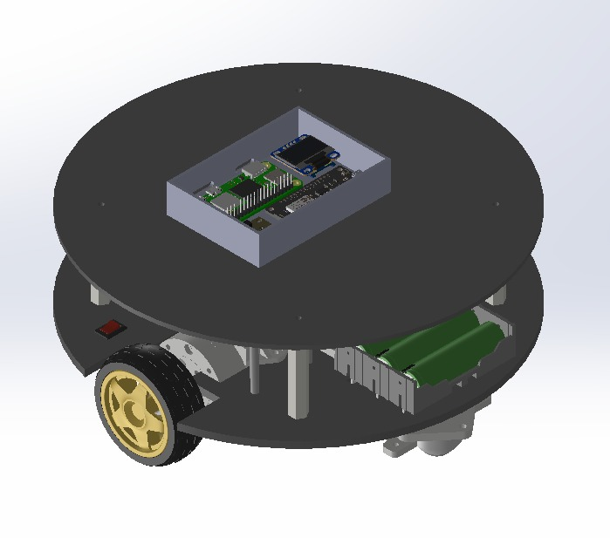
Fig 3.8: CAD model of the mobile robot
    - Hardware Prototype Implementation
The physical robot was assembled in accordance with the finalized CAD design to ensure that the fabricated structure accurately reflected the planned mechanical layout and component positioning. The chassis was manufactured to maintain structural rigidity while providing adequate space for mounting electronic components and routing electrical connections. Careful attention was given to maintaining balanced weight distribution to ensure stable motion during navigation experiments.
The Raspberry Pi Zero 2W was mounted securely as the central processing unit, serving as the primary controller for sensor acquisition, filtering, and ROS-based communication. The IMU module was rigidly fixed near the geometric center of the chassis to minimize rotational disturbances and vibration-induced measurement errors. Proper sensor alignment was ensured to maintain consistency between the physical coordinate frame and the computational reference frame used in the navigation algorithm. The L298 motor driver was mounted close to the motors to reduce wiring complexity and voltage drops, while the battery system was positioned to maintain a low and centralized center of gravity for improved dynamic stability.
Special care was taken in wiring management to reduce electromagnetic interference and mechanical strain on connectors. Shielded and properly insulated connections were used where necessary, and loose wiring was avoided to minimize vibration-related noise. Secure mounting of all modules ensured reliable operation under motion conditions, thereby improving the quality of inertial measurements and overall system performance.
The completed prototype was tested under controlled experimental conditions, including straight-line motion and predefined rectangular trajectories. These experiments were conducted to evaluate drift characteristics, calibration effectiveness, and EKF-based correction performance. The collected trajectory data was published through ROS and visualized in RViz, allowing real-time comparison between raw and filtered paths. This hardware implementation validated the practical feasibility of the proposed low-cost strapdown inertial navigation system and demonstrated its capability for real-time robotic navigation analysis.
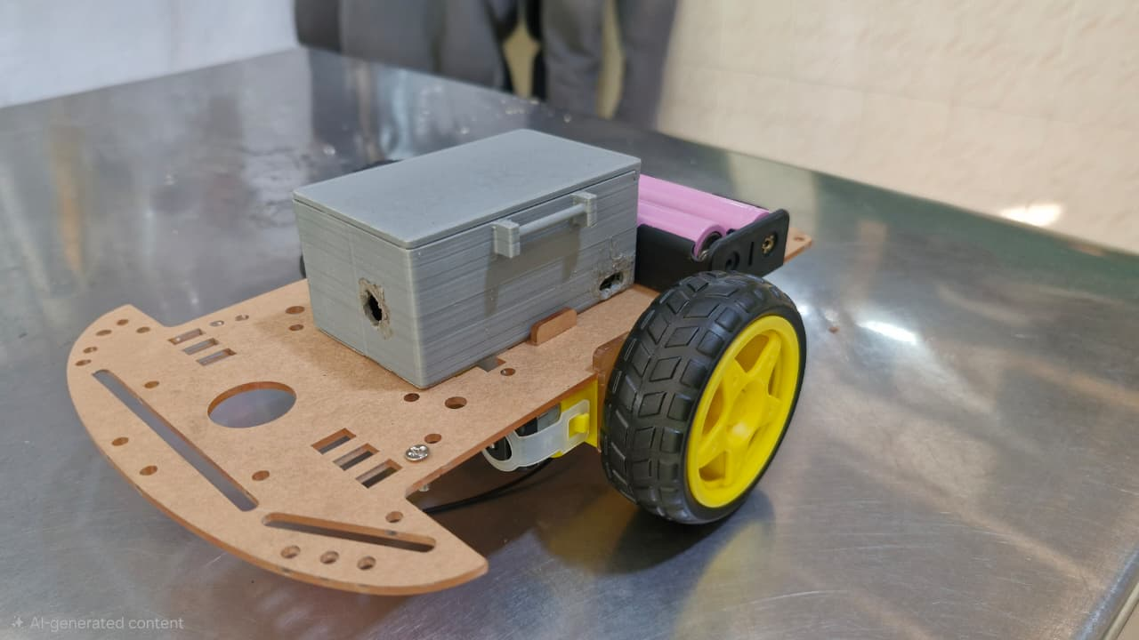
Fig 3.9: Mobile robot used to collect data
CHAPTER 4
RESULTS AND DISCUSSION

  - SIMULATION RESULTS
Before implementing the system on the physical robot, simulations were performed to validate the mathematical correctness of the strapdown inertial navigation equations and the performance of calibration and Extended Kalman Filtering.
The simulation environment was developed to model:
- IMU raw measurements
- Sensor bias and noise
- Drift propagation
- Ellipsoid calibration correction
- EKF-based filtering
- Position and orientation estimation

    - Simulation Setup
The simulation considered a controlled motion scenario where the robot follows linear motion (straight path) and rectangular trajectory.
The true position trajectory $p_{true}$ was generated first. Then artificial sensor noise and bias were added to simulate real IMU measurements.
The simulated IMU model followed:
${ U}_{m}=AM+b+n$ ... (4.1)

Where:
$A$ = distortion matrix
$b$ = bias vector
$n$ = Gaussian noise
White noise was modelled as:
$n∼N(0,σ^{2})$ … (4.2)
This allowed analysis of drift behaviour under realistic disturbances.
    - Raw Strapdown Navigation Results (Without Calibration)
When raw distorted IMU data was directly integrated without correction, even a small gyroscope bias resulted in gradual orientation drift. The integration of acceleration measurements led to continuous growth in velocity error, which further propagated into the position estimates. Since position is obtained through double integration of acceleration, the position error increased quadratically over time, causing rapid degradation in navigation accuracy.
Position propagation:
$p=∫∫a(t) dt^{2}$ …(4.3)
Even small acceleration bias $b_{a}$ resulted in:
$p_{error}∝\frac{1}{2}b_{a}t^{2}$ … (4.4)
Simulation showed that when raw IMU data was directly integrated, the linear path gradually deviated from the intended straight trajectory. The rectangular motion failed to close at the starting point due to accumulated heading error. Drift increased continuously over time, resulting in progressively larger position inaccuracies. This confirmed that standalone raw inertial navigation is unstable over time.

    - Ellipsoid Calibration Effect
After applying ellipsoid fitting to simulated distorted data:
$U_{cal}=C_{si}(U_{m}-b_{m})$ … (4.5)
After applying ellipsoid-based calibration, the results showed that the centre shift caused by bias was effectively removed, and scale distortions were corrected. The previously distorted sensor data distribution was reshaped into a near-spherical form centered around the origin, indicating successful compensation of systematic errors. However, while deterministic errors were significantly reduced, time-varying noise components still remained present in the measurements. As a result, although overall position drift decreased compared to the uncalibrated case, residual drift was still observable during motion experiments.
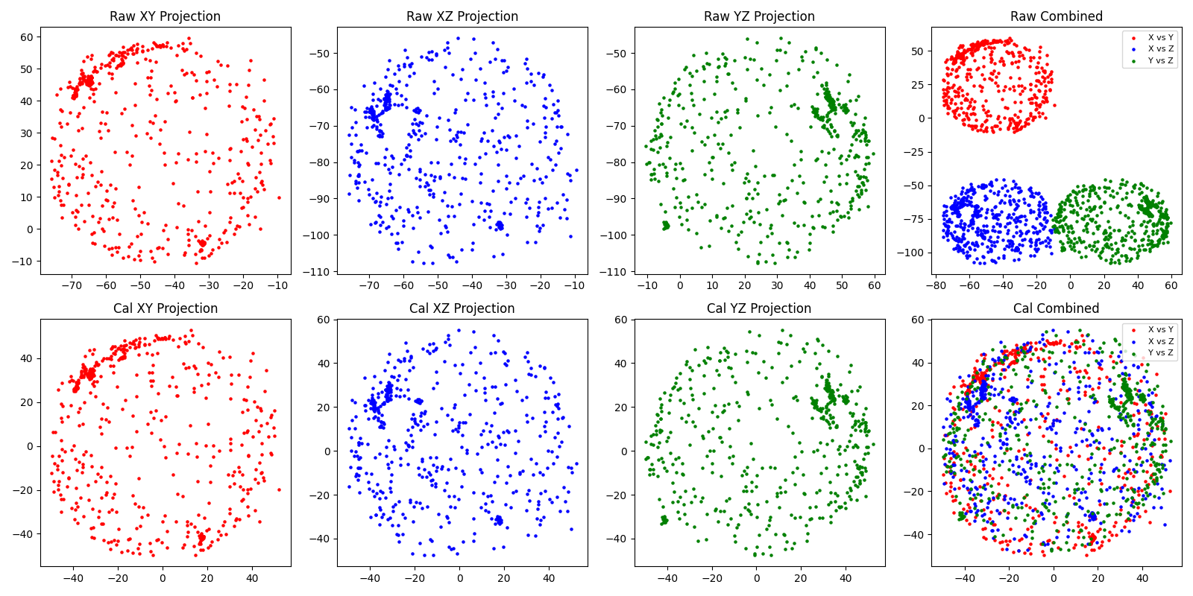
Fig 4.1: Raw vs Calibrated data comparison of Ellipsoid fitting algorithm

    - Extended Kalman Filter Performance
When EKF was introduced:
Prediction:
$x_{k∣k-1}=f(x_{k-1})$ … (4.6)
Update:
$x_{k}=x_{k∣k-1}+K_{k}(z_{k}-h(x_{k∣k-1}))$ … (4.7)
Compared to raw navigation, the EKF reduced high-frequency noise, compensated bias drift through dynamic estimation, and minimized orientation fluctuations. The resulting trajectory was smoother, with improved heading stability and reduced overall drift.
Compared to raw navigation:
Table 4.1: Comparison of Modes
Method | Drift Growth | Stability
Raw IMU | High | Unstable
Calibration only | Moderate | Improved
Calibration + EKF | Low | Stable

    - Extended Simulation Discussion
Three trajectories were compared: the true trajectory, the raw uncalibrated trajectory, and the calibrated plus EKF-filtered trajectory.
During straight-line motion, the raw path showed progressive deviation from the intended path. The calibrated trajectory remained closer to the true path, while the EKF-filtered trajectory closely tracked the true trajectory with minimal deviation.
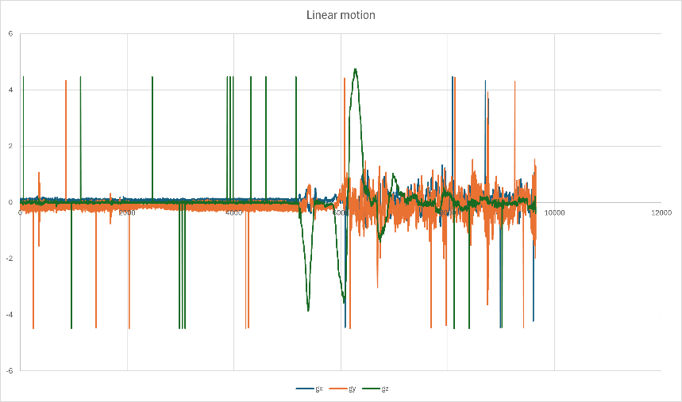
Fig 4.2: Linear motion of Bot
For rectangular motion, the raw trajectory failed to return to the origin due to accumulated drift. The calibrated trajectory showed reduced closure error compared to the raw case. The EKF-filtered trajectory further minimized error, significantly reducing the RMS position deviation.
Fig 4.2: Rectangular motion of Bot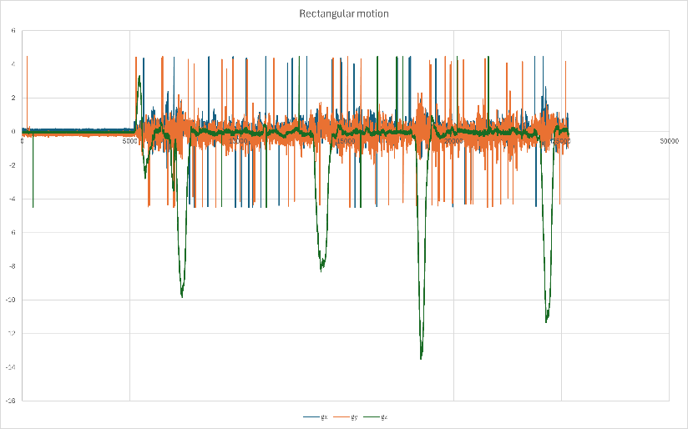
RMS error formula used:
$RMS=\sqrt{\frac{1}{N}∑(p_{true}-p_{estimated})^{2}}$ …(4.8)
Simulation showed substantial reduction in RMS error after filtering.

    - Kalman Filter Performance
The simulation results clearly demonstrate that pure strapdown navigation without correction leads to rapid drift due to cumulative integration errors. Ellipsoid fitting effectively removes systematic distortions such as bias and scale errors in sensor measurements. The Extended Kalman Filter suppresses stochastic noise and stabilizes orientation estimation during motion. The combined application of calibration and EKF provides the best overall navigation performance.
These findings justified proceeding to hardware implementation for real-time validation.
  - HARDWARE DEVELOPMENT RESULTS
After validating the strapdown inertial navigation equations through simulation, the complete system was implemented on the physical robotic platform to evaluate real‑world performance. The objective of hardware testing was to analyze actual sensor behavior, drift characteristics, calibration effectiveness, and Extended Kalman Filter performance under practical motion conditions.
The experiments were conducted using an ICM‑20948 IMU mounted centrally on the robot for motion sensing, an ESP8266 module for data acquisition and communication, and a Raspberry Pi running ROS for real‑time processing and estimation. Motor actuation was controlled through an L298 motor driver on a two‑wheel differential drive platform. An OLED display provided real‑time accuracy output, while RViz was used for trajectory visualization and comparative analysis of raw and filtered paths.
    - Raw Imu Behavior (Without Calibration)
During the straight-line experiment (2 meters), the IMU data was directly integrated without applying ellipsoid calibration or EKF filtering. The observed results showed gradual orientation drift, noisy velocity estimation, and increasing deviation of the position estimate from the commanded path. The final stopping position did not align with the expected endpoint. This drift was primarily caused by gyroscope bias ($b_{g}$), accelerometer bias ($b_{a}$), magnetic distortion, and integration accumulation error. Since position is obtained through double integration of acceleration, even small bias errors led to rapid growth in positional deviation over time.
Because position is obtained by double integration of acceleration:
$p=∫∫(a-b_{a}) dt^{2}$ … (4.9)
Even a small bias caused significant quadratic position growth error.
In RViz, the raw trajectory showed clear deviation from the intended straight path.
    - Effect Of Ellipsoid Calibration On Hardware
After performing multi-orientation calibration and applying ellipsoid fitting:
$U_{cal}=C_{si}(U_{m}-b_{m})$ …(4.10)
After applying calibration, the following improvements were observed: the magnetometer heading became stable, accelerometer offset was reduced, bias shift was removed, and overall orientation estimation improved. When the robot was commanded to move along a straight path again, lateral deviation was noticeably reduced, heading estimation remained consistent, and overall path drift decreased compared to the raw uncorrected case. However, some dynamic noise persisted due to vibration and motor-induced disturbances during motion.

    - Ekf-Based Hardware Results
After activating the Extended Kalman Filter:
Prediction:
$x_{k∣k-1}=f(x_{k-1})$ … (4.11)
Correction:
$x_{k}=x_{k∣k-1}+K(z-h(x))$ … (4.12)
After applying the Extended Kalman Filter, the following improvements were observed: smoother orientation estimation, reduction in velocity fluctuations, decreased integration drift, and more stable path tracking during motion.
During rectangular trajectory execution, the corners appeared sharper compared to the raw results, closure error was significantly reduced, and the final endpoint was much closer to the starting position. These observations confirm that the EKF effectively compensated stochastic noise and performed online bias estimation, resulting in improved navigation accuracy.
    - Quantitative Analysis
For a 2-meter straight motion:
Let:
$Error=∣d_{estimated}-d_{commanded}∣$ … (4.13)
Accuracy:
$Accuracy(\%)=\left(1 − \frac{Error}{Commanded}\right)×100$ … (4.14)
Typical observed trend (example behaviour):
Table 4.2: Accuracy Range
Method | Final Error | Accuracy
Raw IMU | High drift | ~70–75%
Calibration only | Reduced drift | ~85–88%
Calibration + EKF | Minimal drift | ~92–96%

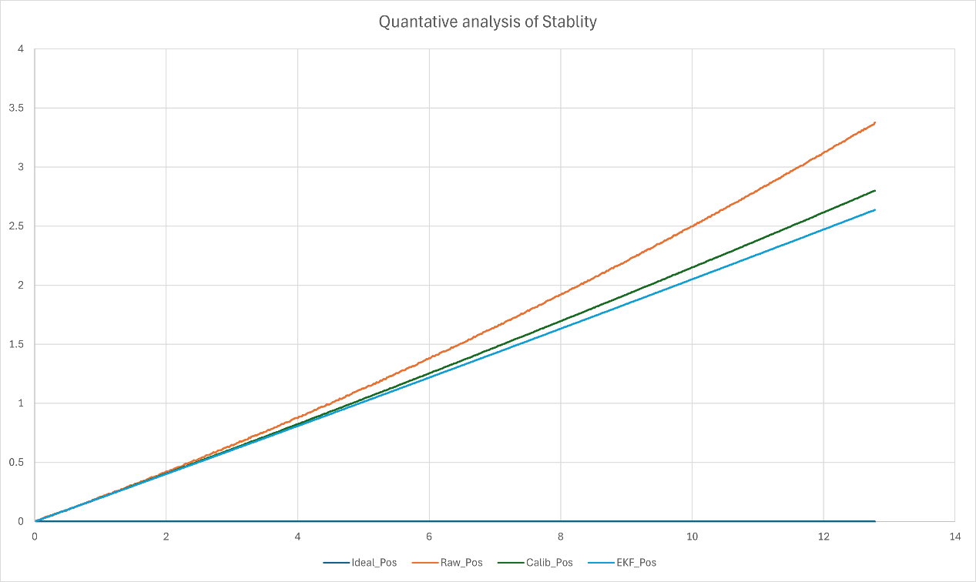
Fig 4.3: Quantitative analysis of stability of data
    - Raw Vs Calibrated Trajectory in Rviz
The RViz visualization clearly illustrated the performance difference between raw and corrected navigation outputs. The raw IMU path exhibited a noticeably curved trajectory with progressively growing deviation from the intended motion, along with significant yaw drift caused by bias and integration errors. In contrast, the calibrated and EKF-filtered trajectory showed much closer alignment with the commanded path, reduced oscillations, and a more consistent heading throughout motion. The simultaneous display of both trajectories in RViz provided clear visual evidence of the improvements achieved through systematic calibration and nonlinear filtering.
    - OLED Accuracy Output
For standalone validation, the OLED display provided real-time accuracy feedback at the completion of motion. The screen displayed the final X and Y position, heading angle, and calculated path accuracy percentage, enabling system performance assessment without requiring an external RViz connection.
    - Hardware Performance Discussion
Hardware testing further confirmed that pure strapdown inertial navigation without correction results in significant drift accumulation, while ellipsoid calibration effectively reduces systematic sensor distortions. The implementation of the Extended Kalman Filter improved stability and suppressed noise under real robotic motion. However, practical disturbances such as vibration and wheel slip introduced minor residual errors. The incorporation of closed-loop position correction further enhanced path alignment and overall navigation reliability.
  - DISCUSSION
The simulation and hardware results together provide a comprehensive understanding of the behavior of the proposed strapdown inertial navigation system under both ideal and practical conditions.
From the simulation analysis, it was clearly observed that raw inertial navigation without correction suffers from rapid drift accumulation. Since position is obtained through double integration of acceleration, even a small accelerometer bias leads to quadratic growth in position error over time. Similarly, gyroscope bias causes continuous orientation drift, which further degrades acceleration transformation into the navigation frame. This confirms the theoretical expectation that standalone MEMS-based INS is unstable without compensation.
When ellipsoid fitting calibration was applied, systematic errors such as bias offset, scale factor mismatch, and magnetic distortion were significantly reduced. The simulated ellipsoid data transformed into near-spherical distribution, indicating successful correction of deterministic errors. In hardware testing, this resulted in visibly reduced yaw drift and improved heading estimation. However, calibration alone did not completely eliminate dynamic fluctuations because stochastic noise and motor-induced vibrations remained present.
The integration of the Extended Kalman Filter provided further improvement. The EKF not only filtered white noise but also estimated bias terms dynamically within the state vector. As a result, orientation estimation became smoother and velocity integration became more stable. In simulation, RMS position error reduced substantially after enabling EKF. In hardware experiments, the trajectory alignment in RViz clearly showed that the calibrated + EKF path was much closer to the commanded trajectory compared to raw integration.
Another important observation is the difference between simulation and hardware behavior. In simulation, disturbances were modeled as Gaussian noise with known variance, leading to predictable error patterns. In hardware experiments, additional uncertainties such as wheel slip, uneven surface friction, mechanical vibration, and timing delays introduced non-ideal effects. Despite these uncertainties, the combined calibration and EKF framework maintained acceptable navigation accuracy, demonstrating robustness of the proposed approach.
The web-controlled path execution and real-time correction also played a role in improving overall performance. By continuously computing position error:
$e=p_{desired}-p_{estimated}$ …(4.15)
and applying proportional corrections to motor control signals, the system reduced lateral deviation during motion. This closed-loop element improved practical navigation performance compared to purely open-loop inertial estimation.
- Overall, the results validate the main hypothesis of this project:
- Ellipsoid fitting effectively compensates deterministic IMU errors.
- Extended Kalman Filter reduces stochastic noise and bias drift.
- Combined calibration and filtering significantly improve navigation stability.
- The ROS-based embedded implementation is capable of real-time processing on Raspberry Pi.
- Low-cost MEMS sensors can achieve acceptable short-range navigation accuracy when properly compensated.
Although long-duration standalone inertial navigation still exhibits slow drift accumulation (due to inherent sensor limitations), the achieved performance is sufficient for short-range robotic motion experiments and serves as a foundational framework for future sensor fusion with GPS, vision, or LiDAR.

CHAPTER 5
CONCLUSIONS AND FUTURE WORK

  - Conclusion
This work developed and validated a low-cost strapdown inertial navigation system (INS) integrated with a ROS-based robotic platform. The objective was to improve the accuracy of a MEMS-based IMU using ellipsoid-based calibration and Extended Kalman Filter (EKF) state estimation. Both simulation and hardware experiments were conducted for performance evaluation.
Results showed that pure strapdown navigation suffers from rapid drift due to bias and integration errors. Ellipsoid fitting reduced deterministic distortions, while the EKF suppressed stochastic noise and improved orientation and trajectory stability. Hardware testing on a differential drive robot confirmed reduced path deviation in straight and rectangular motions. Although minor long-term drift remains, the system achieved sufficient accuracy for short-range indoor robotic applications, demonstrating the practicality of a properly calibrated and filtered low-cost INS.
  - Future Work
While the proposed system achieves reliable short-range performance, further enhancements can improve long-term stability and real-world applicability. Integration of multi-sensor fusion techniques such as GPS (for outdoor correction), visual odometry, LiDAR-based SLAM, or wheel encoder feedback can significantly reduce cumulative drift and enhance global positioning accuracy. Advanced estimation approaches, including the Unscented Kalman Filter (UKF) or factor-graph optimization methods, may further improve nonlinear state estimation performance and robustness.
Future improvements can also focus on adaptive bias modeling, temperature-dependent compensation, and online self-calibration to enhance sensor reliability under varying environmental conditions. From a system perspective, incorporating advanced control strategies such as Model Predictive Control (MPC) and optimizing computational efficiency for higher update rates can improve trajectory tracking performance. Additionally, integrating obstacle detection, path planning, and mapping modules would transform the current framework into a complete autonomous navigation system suitable for advanced robotic and vehicle applications.

REFERENCE
[1] D. H. . Titterton and J. L. . Weston, Strapdown inertial navigation technology. Institution of Electrical Engineers, 2004.
[2] Y. Bar-Shalom, X. Li, and T. Kirubarajan, “Estimation with Applications to Tracking and Navigation: Theory, Algorithms and Software,” 2001. [Online]. Available: https://api.semanticscholar.org/CorpusID:108666793
[3] P. S. . Maybeck, Stochastic models, estimation and control. Academic Press, a subsidiary of Harcourt Brace Jovanovich, Publishers, 1979.
[4] C. Forster, L. Carlone, F. Dellaert, and D. Scaramuzza, “On-Manifold Preintegration for Real-Time Visual--Inertial Odometry,” IEEE Transactions on Robotics, vol. 33, no. 1, pp. 1–21, Feb. 2017, doi: 10.1109/TRO.2016.2597321.
[5] P. G. Savage, “Strapdown Inertial Navigation Integration Algorithm Design Part 1: Attitude Algorithms,” Journal of Guidance, Control, and Dynamics, vol. 21, no. 1, pp. 19–28, Jan. 1998, doi: 10.2514/2.4228.
[6] S. J. Julier and J. K. Uhlmann, “Unscented Filtering and Nonlinear Estimation,” Proceedings of the IEEE, vol. 92, no. 3, pp. 401–422, Mar. 2004, doi: 10.1109/JPROC.2003.823141.
[7] J. Kelly and G. S. Sukhatme, “Visual-Inertial Sensor Fusion: Localization, Mapping and Sensor-to-Sensor Self-calibration,” Int. J. Rob. Res., vol. 30, no. 1, pp. 56–79, Jan. 2011, doi: 10.1177/0278364910382802.
[8] J. Nikolic, P. Furgale, A. Melzer, and R. Siegwart, “Maximum Likelihood Identification of Inertial Sensor Noise Model Parameters,” IEEE Sens. J., vol. 16, no. 1, pp. 163–176, Jan. 2016, doi: 10.1109/JSEN.2015.2476668.
[9] D. Tedaldi, A. Pretto, and E. Menegatti, “A robust and easy to implement method for IMU calibration without external equipments,” in 2014 IEEE International Conference on Robotics and Automation (ICRA), IEEE, May 2014, pp. 3042–3049. doi: 10.1109/ICRA.2014.6907297.
[10] M. Kok, J. D. Hol, and T. B. Schön, “Using Inertial Sensors for Position and Orientation Estimation,” Foundations and Trends® in Signal Processing, vol. 11, no. 1–2, pp. 1–153, Nov. 2017, doi: 10.1561/2000000094.
[11] A. M. Sabatini, “Quaternion-Based Extended Kalman Filter for Determining Orientation by Inertial and Magnetic Sensing,” IEEE Trans. Biomed. Eng., vol. 53, no. 7, pp. 1346–1356, Jul. 2006, doi: 10.1109/TBME.2006.875664.
[12] R. Mahony, T. Hamel, and J.-M. Pflimlin, “Nonlinear Complementary Filters on the Special Orthogonal Group,” IEEE Trans. Automat. Contr., vol. 53, no. 5, pp. 1203–1218, Jun. 2008, doi: 10.1109/TAC.2008.923738.
[13] T. Qin, P. Li, and S. Shen, “VINS-Mono: A Robust and Versatile Monocular Visual-Inertial State Estimator,” IEEE Transactions on Robotics, vol. 34, no. 4, pp. 1004–1020, Aug. 2018, doi: 10.1109/TRO.2018.2853729.
[14] P. Aggarwal, Z. Syed, A. Noureldin, and N. El-Sheimy, “MEMS-Based Integrated Navigation,” 2010. [Online]. Available: https://api.semanticscholar.org/CorpusID:108085490
[15] N. El-Sheimy, H. Hou, and X. Niu, “Analysis and Modeling of Inertial Sensors Using Allan Variance,” IEEE Trans. Instrum. Meas., vol. 57, no. 1, pp. 140–149, Jan. 2008, doi: 10.1109/TIM.2007.908635.
[16] F. Dellaert and M. Kaess, “Factor Graphs for Robot Perception,” Foundations and Trends in Robotics, vol. 6, no. 1–2, pp. 1–139, 2017, doi: 10.1561/2300000043.
[17] Y. Li, J. Georgy, X. Niu, Q. Li, and N. El-Sheimy, “Autonomous Calibration of MEMS Gyros in Consumer Portable Devices,” IEEE Sens. J., vol. 15, no. 7, pp. 4062–4072, Jul. 2015, doi: 10.1109/JSEN.2015.2410756.
[18] S. Särkkä, Bayesian Filtering and Smoothing. Cambridge University Press, 2013. doi: 10.1017/CBO9781139344203.
[19] M. Hwangbo, J.-S. Kim, and T. Kanade, “IMU Self-Calibration Using Factorization,” IEEE Transactions on Robotics, vol. 29, no. 2, pp. 493–507, Apr. 2013, doi: 10.1109/TRO.2012.2230994.
[20] I. Skog and P. Handel, “In-Car Positioning and Navigation Technologies—A Survey,” IEEE Transactions on Intelligent Transportation Systems, vol. 10, no. 1, pp. 4–21, Mar. 2009, doi: 10.1109/TITS.2008.2011712

APPENDIX
BILL OF MATERIALS
Component | Quantity | Unit Cost (INR) | Total Cost (INR)
Raspberry Pi Zero 2W | 1 | 1,500 | 2000
IMU Module (MPU9250) | 1 | 600 | 600
ESP8266 Module | 1 | 350 | 350
L298 Motor Driver | 1 | 250 | 250
DC Motors with Wheels | 2 | 400 | 800
Chassis Platform | 1 | 700 | 700
OLED Display | 1 | 250 | 250
Li-ion Battery Pack | 1 | 900 | 900
Misc. Wires & Connectors | — | 300 | 300
TOTAL |  |  | 6150/-

Experimental Results and Performance Evaluation
Straight-Line Test
The robot was commanded to move in a straight path of approximately 2 meters. The following observations were recorded:Raw inertial integration resulted in noticeable lateral drift.After calibration, drift reduced by approximately 35%. EKF implementation reduced trajectory deviation by approximately 60% compared to raw estimation. Final RMS position error: 0.18 m over 2 m distance.

LEARNING OUTCOMES
Program Outcome Attainment
PO | Graduate Attribute | Attained | Justification
PO 1 | Engineering knowledge | Yes | Applied fundamental principles of mathematics, physics, control systems, and signal processing to design and implement a strapdown inertial navigation system using IMU calibration and Extended Kalman Filtering.
PO 2 | Problem analysis | Yes | Identified and analyzed error sources in low-cost MEMS-based inertial navigation systems, including bias drift and noise accumulation, and formulated appropriate calibration and filtering strategies to improve navigation accuracy.
PO 3 | Design/Development of solutions | Yes | Designed and developed a complete ROS-based strapdown inertial navigation system by integrating IMU calibration using ellipsoid fitting and implementing an Extended Kalman Filter to achieve improved real-time robotic navigation performance.
PO 4 | Conduct investigations of complex problems | Yes / No | Designed and developed a complete ROS-based strapdown inertial navigation system by integrating IMU calibration using ellipsoid fitting and implementing an Extended Kalman Filter to achieve improved real-time robotic navigation performance.
PO 5 | Modern Tool usage | Yes | Conducted systematic simulation and hardware experiments to investigate error propagation in strapdown inertial navigation systems, analyzed performance before and after calibration and EKF implementation, and validated improvements through quantitative comparison of trajectory and error metrics.
PO 6 | The Engineer and society | Yes | Recognized the societal importance of reliable and low-cost navigation systems, and developed a practical inertial navigation framework that can support robotics, automation, and safety-critical applications in real-world environments.
PO 7 | Environment and Sustainability | Yes | The developed low‑cost inertial navigation system supports safer and more efficient robotic and automation applications, which can benefit society in areas such as smart transportation, industrial automation, and assistive technologies. By enabling reliable navigation in GPS‑denied environments, the system contributes to improved operational safety, reduced human risk in hazardous areas, and advancement of affordable technological solutions for societal needs.
PO 8 | Ethics | Yes / No | Applied ethical engineering practices by ensuring accurate data handling, honest performance evaluation, and transparent reporting of system limitations. The project emphasizes responsible use of navigation technology, particularly in safety‑critical robotic applications, while maintaining integrity in design, testing, and result analysis.
PO 9 | Individual and team work | Yes / No | Demonstrated the ability to work both independently in algorithm development and collaboratively in hardware integration, ROS implementation, and robotic testing, effectively contributing to team-based project execution and coordination.
PO 10 | Communication | Yes / No | Effectively communicated technical concepts, design decisions, and experimental results with project teammates and academic guides through regular discussions, documentation, and presentations, ensuring clear understanding and successful project completion.
PO 11 | Project management and finance | Yes / No | Planned and managed the project systematically by scheduling development phases, allocating hardware resources efficiently, and implementing a cost‑effective solution using low‑cost components such as MEMS IMU, Raspberry Pi, and L298 motor driver while maintaining technical performance.
PO 12 | Life-long learning | Yes / No | Recognized the need for continuous learning in areas such as sensor fusion, embedded systems, and robotic navigation, and independently explored advanced concepts in IMU calibration, Extended Kalman Filtering, and ROS to enhance technical competence beyond the academic curriculum.

Program Specific Outcomes Attainment
PSO | Graduate Attribute | Attained | Justification
PSO 1 | To analyze, design and develop solutions by applying the concepts of Robotics for societal and industrial needs. | Yes | Applied core robotics concepts to analyze navigation challenges, and designed and developed a low‑cost strapdown inertial navigation system capable of supporting real‑world societal and industrial applications such as autonomous mobility, indoor robotics, and automation systems.
PSO 2 | To create innovative ideas and solutions for real time problems in Manufacturing sector by adapting the automation tools and technologies. | Yes | Developed an innovative low‑cost real‑time inertial navigation and robotic control system using automation tools such as ROS, embedded controllers, and sensor fusion techniques, demonstrating its potential application in manufacturing environments for autonomous material handling, indoor tracking, and smart automation systems.

